A walkthrough example of a faculty member requesting a manual review from the appropriate Chairperson.
- The chairperson will receive an automated email with the subject “Grade Grievance Form - Requesting Manual Review”.
  - The email includes the student, course, and instructor details.
  - Note: The instructor’s deadline is not paused during this process, they can petition the Provost for an extension of time if needed.
  - Note: If the Chairperson is also the course instructor, the appropriate Dean(s) will receive the email instead.
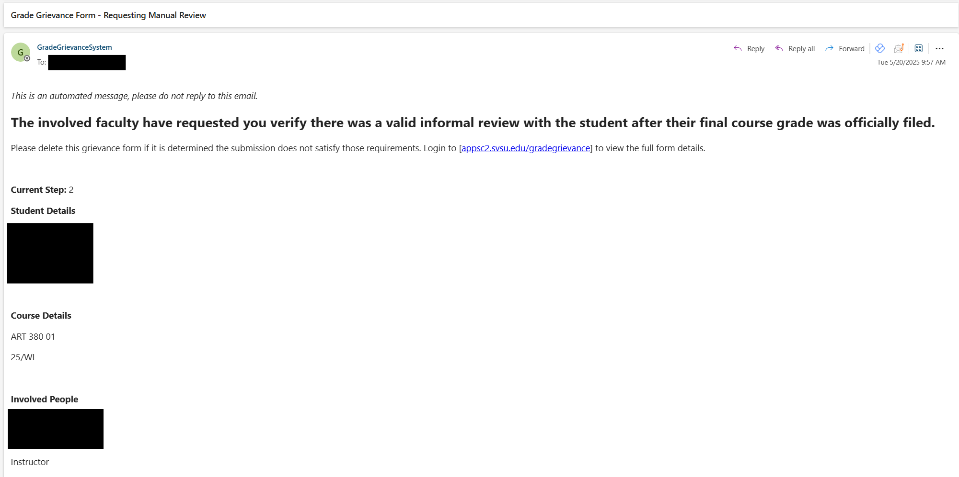
- The Chair will login to https://appsc2.svsu.edu/gradegrievance
- The Chair will click on the “Main Menu” dropdown, then click “View All Recent Semester Form Submissions”
  - On this page Chairs and Deans can view all grievance form submissions for the previous semester within their academic department.
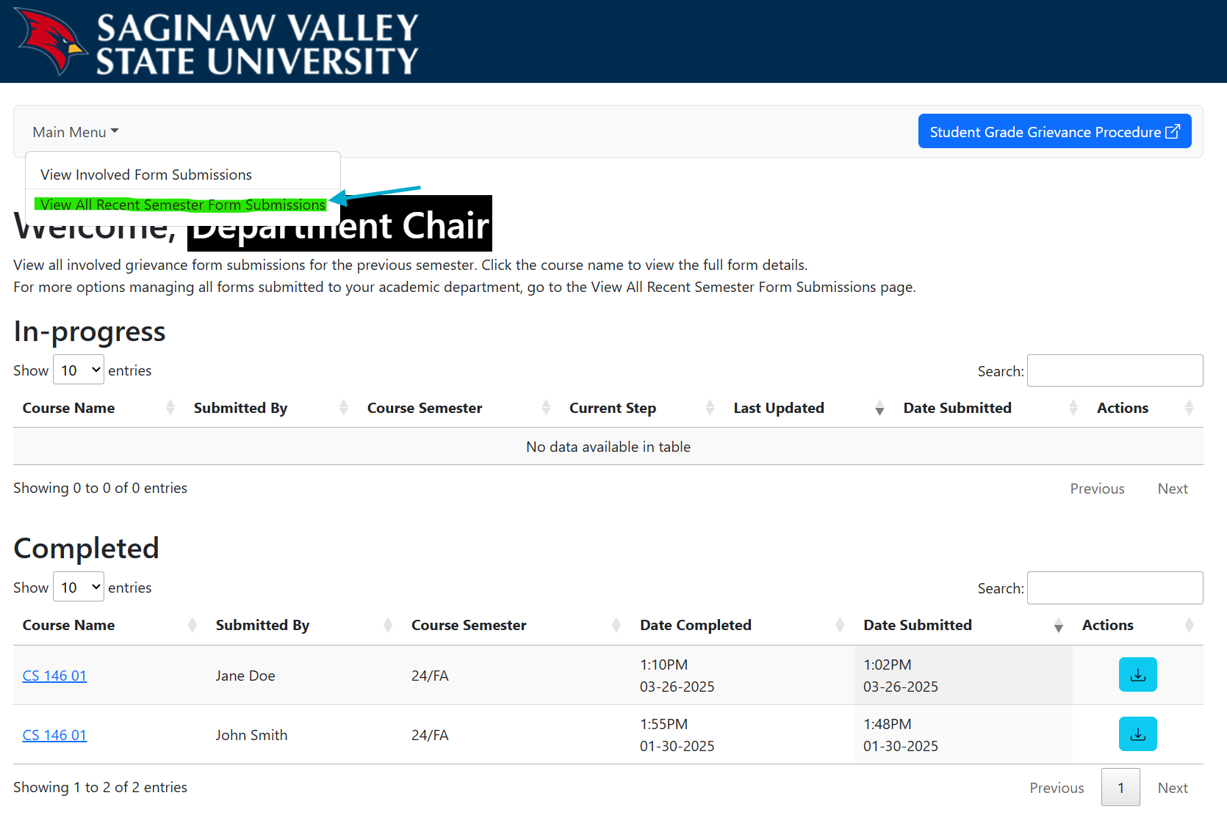

- The “View All Recent Semester Form Submissions” page has additional actions for managing all forms submitted to an academic department, like deleting and re-opening forms.
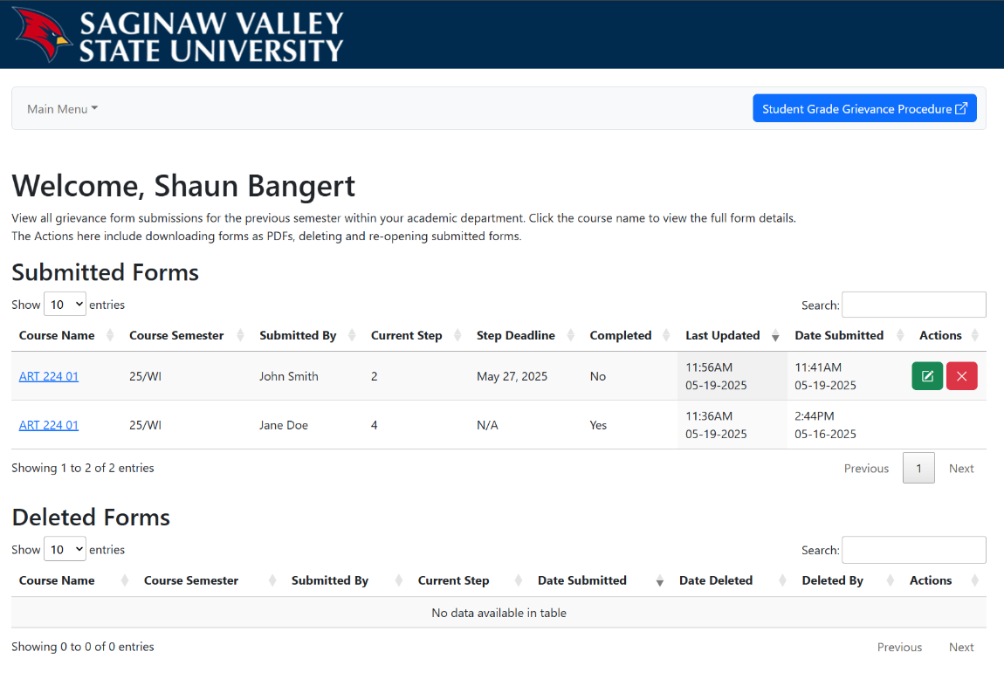
Department Chair

- The Chair will find and click on the corresponding grade grievance to view the form details.
- Note: Under the “Grievance Information” section, all uploaded evidence files can be downloaded for review by clicking the arrow icon to the right of the file name.
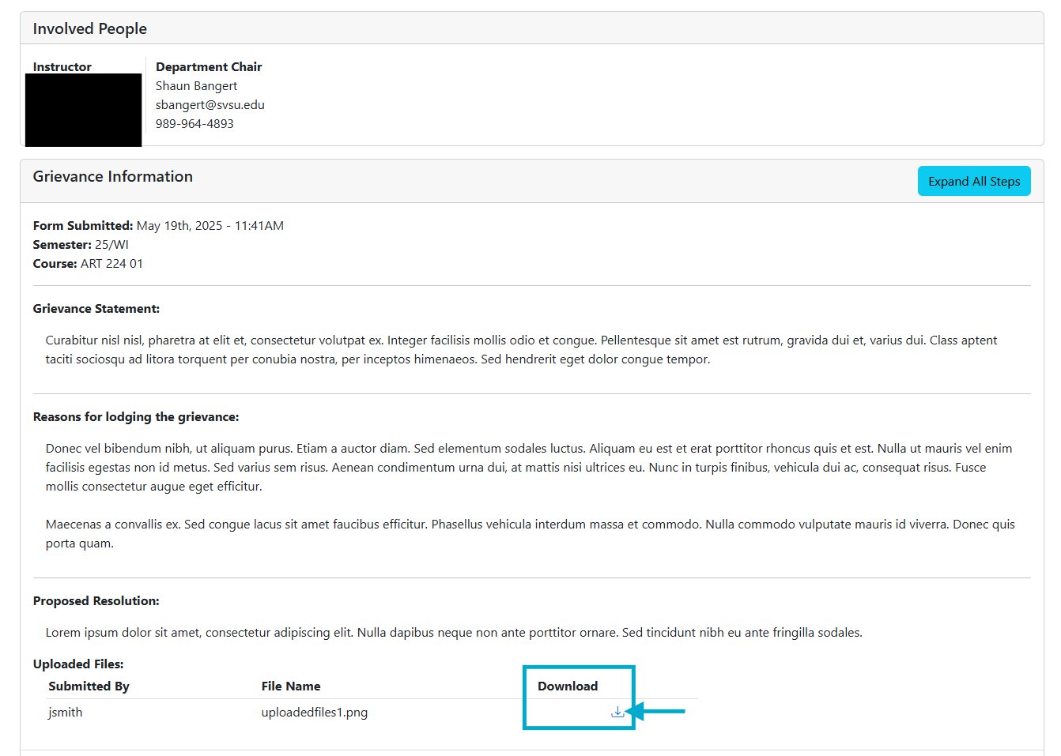

After reviewing the grievance details and uploaded evidence files, the Chair should communicate with both the student and faculty to make a final determination that the student satisfied the Step 1 informal review requirements.
- This communication happens outside the grade grievance online application.
  - If the Chair determines the form is valid the process continues normally.
- In this example, the Chair determined the student did not meet the Step 1 informal review requirements, so it should be deleted.

How to delete an invalid grade grievance form
- The Chair or Dean will login to https://appsc2.svsu.edu/gradegrievance, click on the “Main Menu” dropdown, then click “View All Recent Semester Form Submissions”.
- In the “Submitted Forms” table, they will click the red “X” icon next to the corresponding grievance.
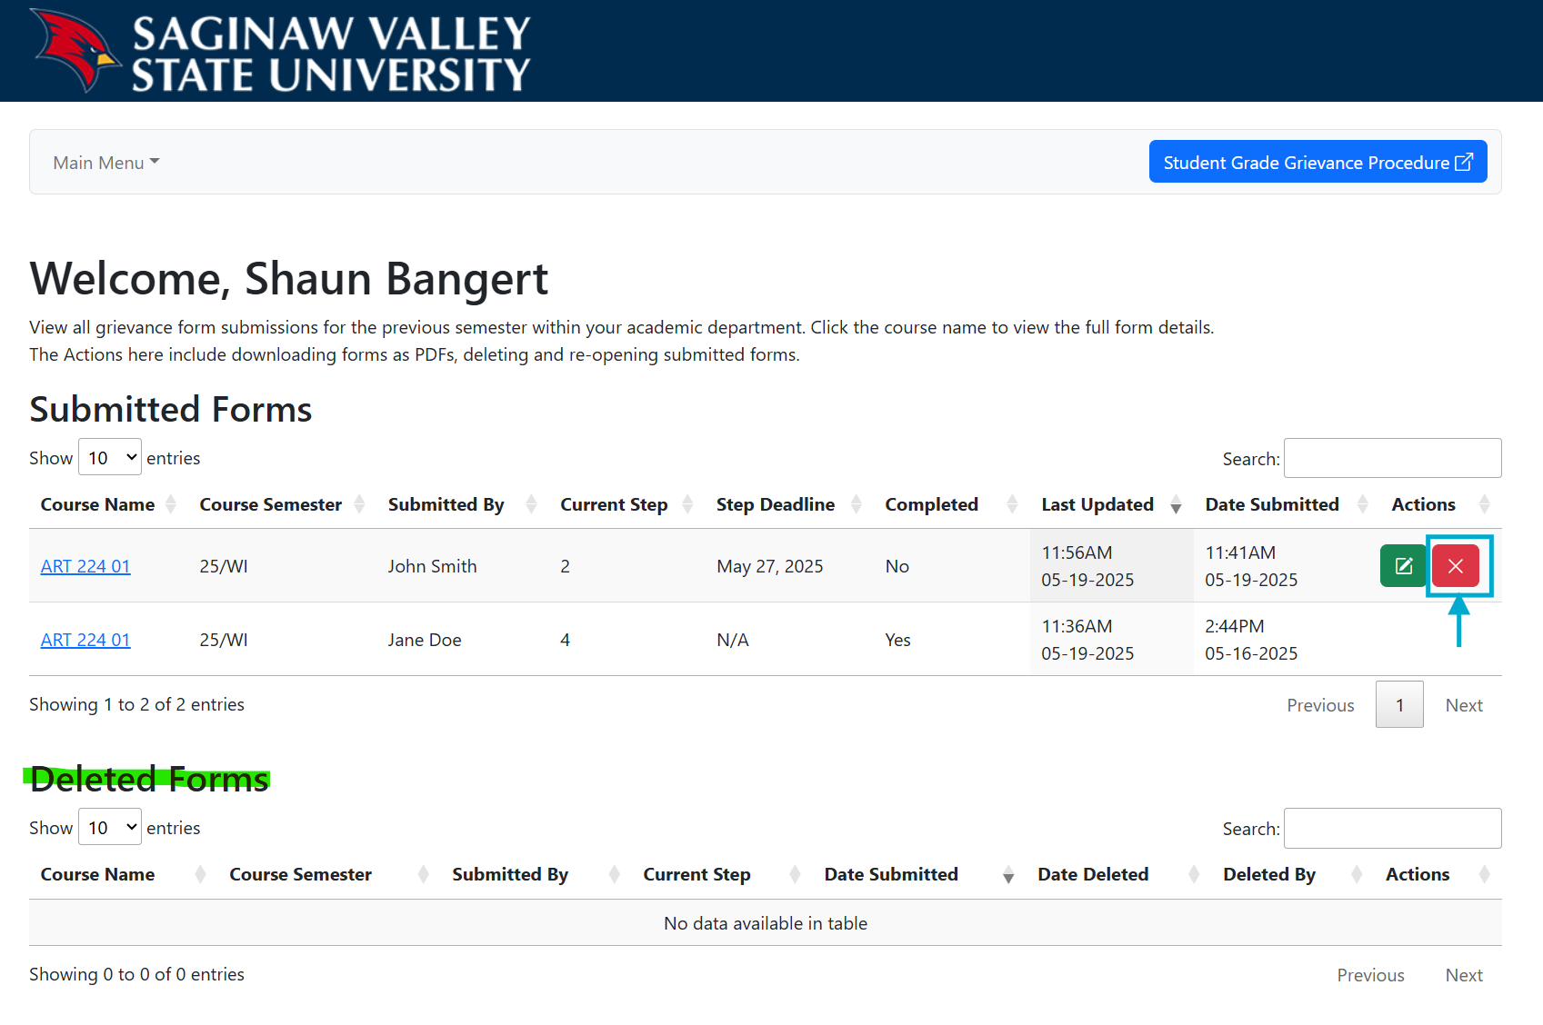
Department Chair
- A confirmation popup will appear, and the Chair or Dean will enter their “reason for deleting the form” before clicking the “Delete Grievance Form” button on the popup.
  - A notification email is sent to the student, instructors, Chair, Deans and student association.
  - Note: Chairs can delete all Step 2 and 3 forms within their academic department. Deans can delete all forms within their academic department up to Step 4 before a committee hearing meeting is scheduled.
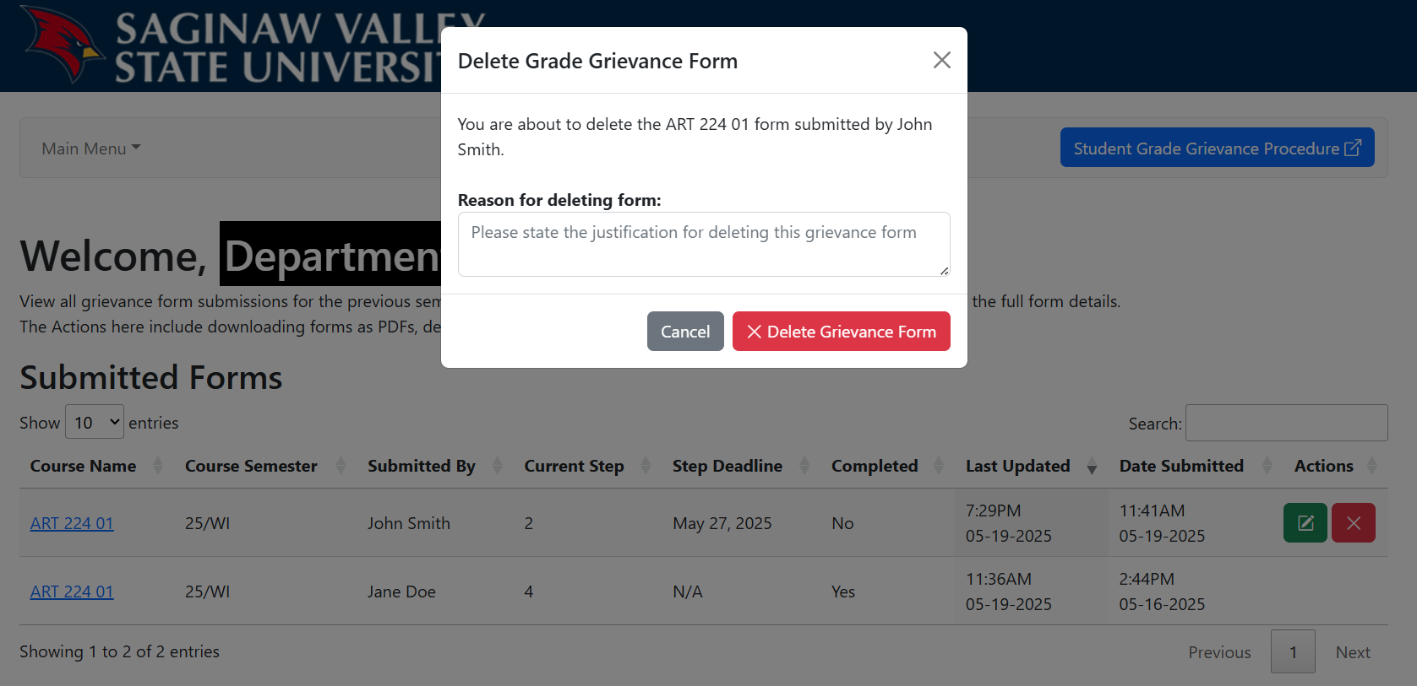
- For record keeping purposes, the grievance form is archived and moved into the “Deleted Forms” section of the “View All Recent Semester Form Submissions” page.
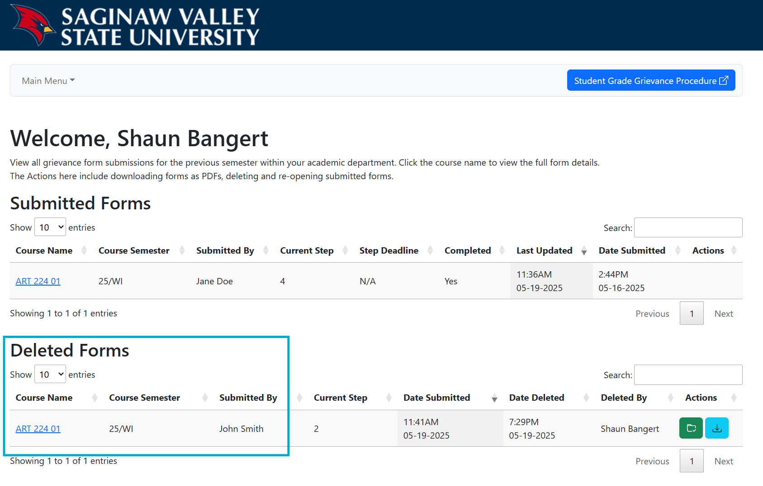
  - Note: Students and instructors will no longer be able to view the form, it will only be available to Chairs, Deans and the Provost’s office.
Department Chair

How to re-open a deleted grade grievance form
- If a form is accidentally deleted or needs to be re-opened for any reason. The appropriate Chair or Dean can re-open the grievance.
- They will login to https://appsc2.svsu.edu/gradegrievance, click on the “Main Menu” dropdown, then click “View All Recent Semester Form Submissions”
- In the “Deleted Forms” table, they will click the green folder icon next to the corresponding grievance.
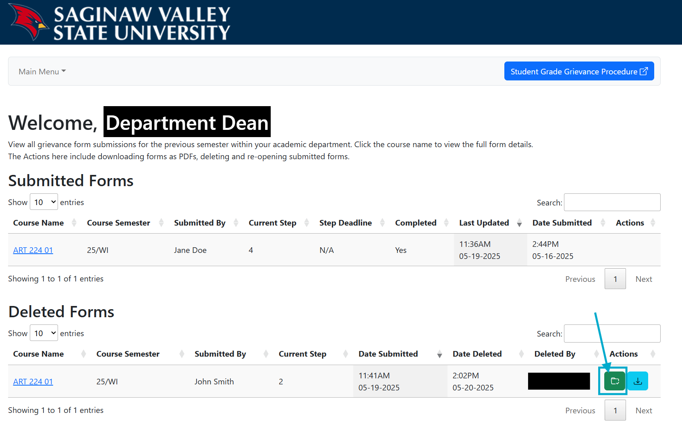
- A confirmation popup will appear, and the Chair or Dean will click the “Re-open Grievance Form”.
  - An email confirmation is sent to the student, instructor, Chair, Deans and student association.
  - Note: A new deadline will be automatically applied starting from the next business day after re-opening the grievance form.
